|  |  |  |  |  |
| --- | --- | --- | --- | --- |
| **Class** | **SE18xx** | **Group** | **01** | **Contribution** |
| **#** | **Student ID** | **Student Name** | **Task** | **(0-100%)** |
| 1 | SE183004 | Nguyễn Ngọc Minh | Fullstack | 100% |
| 2 | SE183802 | Đặng Kiến Ninh | Fullstack | 100% |
| 3 | SE182981 | Lê Nguyễn Tuấn Nghĩa | Fullstack | 100% |
| 4 |  |  |  |  |
| 5 |  |  |  |  |

**IOT 102: PROGRESS TEST 1**

**DO NOT COPY**

**Components**: Arduino Uno,…

Input: ultrasonic rangefinder, Keypad 4x4, photoresistor, temperature sensor, PIR sensor, soil moisture sensor, gas sensor

Output: servo motor, LCD, LED 7 segment, 8x8 LED matrix, buzzer…

**Task**: The student designs a system that implements at least three different input devices, three different output devices mentioned above, and at least one advanced component (Wifi, Bluetooth, LoRa).

For example:

* A thief warning system (input: ultrasonic rangefinder, PIR + button, output: buzzer + LCD,…)
* A digital clock with temperature (DS1307, display in 8x8 led matrix + buzzer,…)
* A watering system (soil moisture sensor, water pump,…)
* A fire alarm system (temperature + gas sensor,…)

**Reference:**

<https://circuitdigest.com/internet-of-things-iot-projects>

<https://www.pinterest.com/iotprojectsideas/arduino-and-iot-projects/>

<https://iotdesignpro.com/iot-arduino-projects>

**Answer**

1. **Description**: (*explain the detailed operation of your system*)

- Product: SMART DOOR.

- When someone approaches the door, the ultrasonic rangefinder starts measuring the distance. If the distance is within 0-50 cm, the system works.

- First the LED will light up, along with the LCD screen will also be opened with the request "Enter Password".

- Password displayed in Serial. (correct password is 0000)

- If entered correctly, the message "Opened" will appear on the LCD screen and the door can be opened (Potentiometer represents the door handle and servo motor represents the door).

- If entered incorrectly, the message "Failed" will appear on the LCD screen and the door cannot be opened.

- If you pass by without doing anything or stand in front of the door for a while without entering the password, the light and screen will light up for a while and then turn off.

1. **Block diagram:**

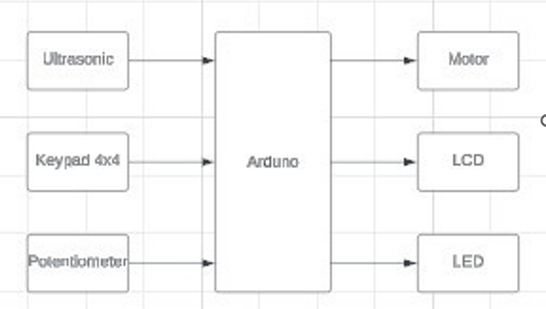

1. **Picture of your design:**

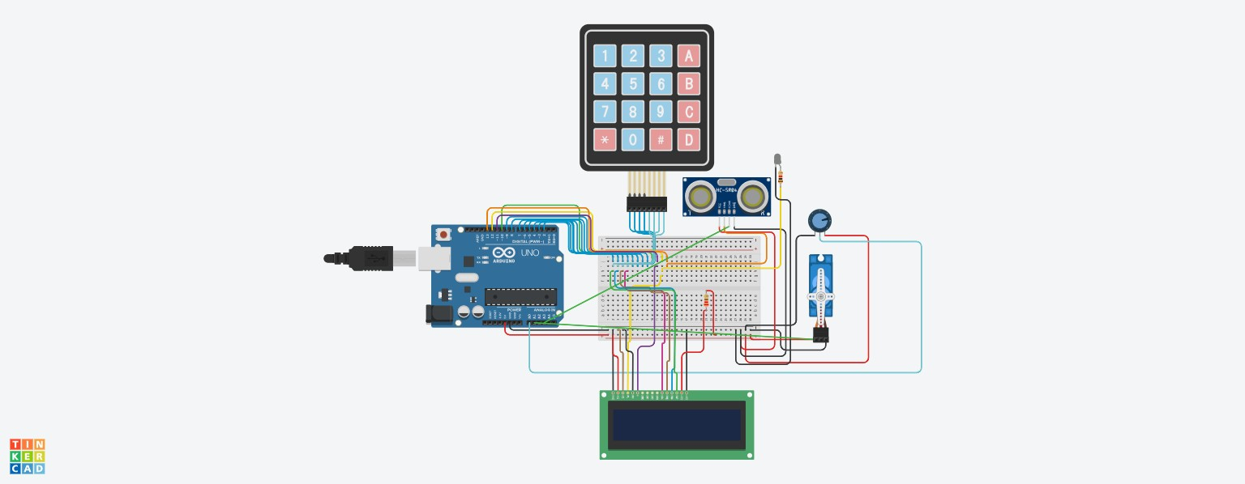

1. **Flowchart (algorithm)**

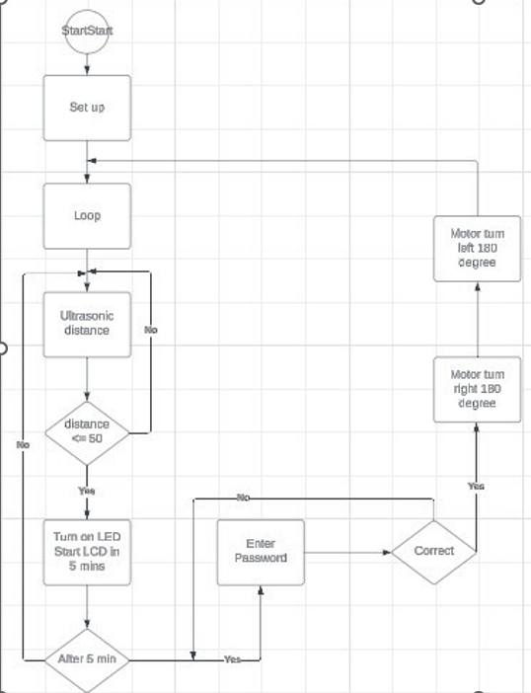

1. **Code:**

**// the setup function runs once when you press reset or power the board**

**#include <Keypad.h>**

**#include <string.h>**

**#include <LiquidCrystal.h>**

**#include <Servo.h>**

**Servo myservo; // create servo object to control a servo**

**int potpin = 0; // analog pin used to connect the potentiometer**

**int val; // variable to read the value from the analog pin**

**const unsigned int TRIG_PIN=13;**

**const unsigned int ECHO_PIN=A3;**

**const unsigned int BAUD_RATE=9600;**

**int led = 12;**

**const int rs = 12, en = 11, d4 = 5, d5 = 4, d6 = 3, d7 = 2;**

**LiquidCrystal lcd(rs, en, d4, d5, d6, d7);**

**const byte ROWS = 4;**

**const byte COLS = 4;**

**//Định nghĩa các giá trị trả về**

**char hexaKeys[ROWS][COLS] = {**

**{'1', '2', '3', 'A'},**

**{'4', '5', '6', 'B'},**

**{'7', '8', '9', 'C'},**

**{'*', '0', '#', 'D'}**

**};**

**byte rowPins[ROWS] = {9, 8, 7, 6};**

**byte colPins[COLS] = {5, 4, 3, 2};**

**//cài đặt thư viện keypad**

**Keypad customKeypad = Keypad(makeKeymap(hexaKeys), rowPins, colPins, ROWS, COLS);**

**void setup() {**

**myservo.attach(10); // attaches the servo on pin 9 to the servo object**

**pinMode(TRIG_PIN, OUTPUT);**

**pinMode(ECHO_PIN, INPUT);**

**Serial.begin(BAUD_RATE);**

**pinMode(led, OUTPUT);**

**lcd.begin(16, 2);**

**Serial.begin(9600);//bật serial, baudrate 9600**

**}**

**void add(char* key, char c, int *size){**

**if (*size >= 4) {**

**// Array is full, handle error or resize if possible**

**return;**

**}**

**key[(*size)++] = c;**

**}**

**char password[4] = {'0', '0', '0', '0'};**

**char myChars[4];**

**int numElements; // Initialize with 5 characters**

**bool areArraysEqual(char *array1, char *array2, int size1, int size2) {**

**if (size1 != size2) {**

**return false;**

**}**

**for (int i = 0; i < size1; i++) {**

**if (array1[i] != array2[i]) {**

**return false;**

**}**

**}**

**return true;**

**}**

**int count = 0;**

**int count2 = 0;**

**// the loop function runs over and over again forever**

**void loop() {**

**digitalWrite(TRIG_PIN, LOW);**

**delayMicroseconds(2);**

**digitalWrite(TRIG_PIN, HIGH);**

**delayMicroseconds(10);**

**digitalWrite(TRIG_PIN, LOW);**

**const unsigned long duration = pulseIn(ECHO_PIN, HIGH);**

**int distance = duration/29/2;**

**//Serial.println(distance);**

**//delay(100000);**

**if (distance <= 100) {**

**digitalWrite(led, HIGH);**

**delay(2000);**

**lcd.setCursor(0, 0);**

**Serial.println("nhap pass ne");//**

**lcd.print("Enter password!!!");**

**numElements = 0;**

**count2 = 0;**

**while (numElements < 4) {**

**char customKey = customKeypad.getKey();**

**if (customKey) {**

**add(myChars, customKey, & numElements);**

**}**

**delay(15);**

**count2++;**

**if (count2 >= 666) {**

**break;**

**}**

**}**

**for (int i = 0; i < numElements; i++) {**

**Serial.print(myChars[i]);**

**}**

**Serial.print("check pass ne: ");//**

**if (count2 < 666) {**

**delay(2000);**

**if (areArraysEqual(password, myChars, 4, numElements)) {**

**Serial.println("dung");//**

**delay(2000);**

**lcd.begin(16,2);**

**delay(2000);**

**lcd.setCursor(0, 0);**

**lcd.print("Opened!!!");**

**count = 0;**

**while (1 == 1) {**

**Serial.println("mo khoa nut van");**

**val = analogRead(potpin**

**val = map(val, 0, 1023, 0, 180);**

**myservo.write(val);**

**delay(15);**

**count++;**

**if (count >= 666) {**

**break;**

**}**

**}**

**} else {**

**Serial.println("sai");//**

**delay(1000);**

**lcd.begin(16,2);**

**delay(2000);**

**lcd.setCursor(0, 0);**

**lcd.print("Failed!!!");**

**}**

**} else {**

**Serial.println("khong nhap pass");//**

**digitalWrite(led, LOW);**

**lcd.begin(16,2);**

**delay(2000);**

**}**

**}**

**}**

1. **Tinkercad link:**

**https://www.tinkercad.com/things/aU84OWZKDcP-pt1/editel?sharecode=_4nMGZJwuZ6FTvPCiNmU4dV0GzHUx5wuTvOUugnlLvI**

1. **Video clip (Google Drive):**

**https://drive.google.com/drive/folders/1-9U9XfScOzhSh7-zsCiU2twgQybfOWlI?fbclid=IwAR3DHzHi3Exocil5Q51RGLTQ3w9qmnbW44_uWqb4NwRAOE2AZhqSs-hlW1E**